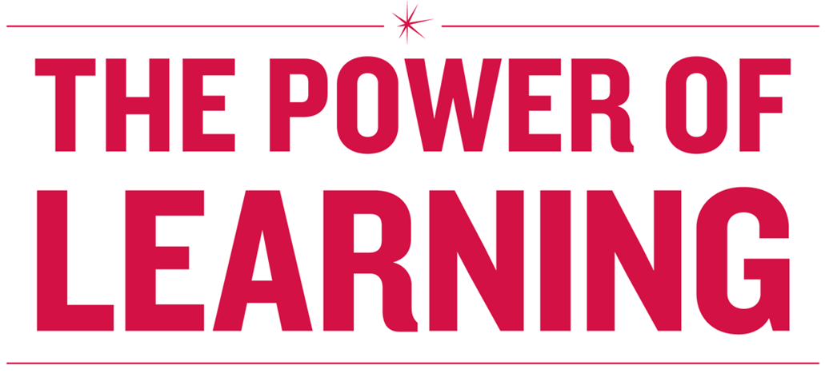

**POWER HOUR:**

**Rock Star Meetings**

# Core Competencies

# Lead, Facilitate, Manage

* Host productive and engaging meetings.
* Create an environment where meetings and the contributions others provide at meetings are valued.
* Facilitate meetings in a way that promotes creative thinking.
* Determine how to contribute the most value to any meeting you attend.
* Create an environment that encourages the team to challenge the status quo; promote innovative ways of looking at problems and processes.

**Measures**

* Fewer post- and pre- meetings.
* Productive dialogue and conflict in meetings
* Employee Survey results show favorable and/or trending up, particularly Employee Engagement Index, Diversity Index and Supervisory Index.
* Team is making process improvements, sharing ideas and championing innovative approaches.
* Employees outside the organization want to work on the team (e.g. apply for open positions).

# Table of Contents

Core Competencies 2

Lead, Facilitate, Manage 2

Table of Contents 3

Warm Up Activity 6

5 Steps to a Rock Star Meeting 7

Prepare 8

Engage & Participate 10

Execute 11

Follow Through 12

Establish Ground Rules 12

Monthly Meeting Template 13

Meeting Agenda Activity 14

Assess a Meeting 15

Setting Your Agenda Use this for activity 16

Group Debrief 17

Appendix A: Sample Team Agenda (Source: manager-tools.com) 18

Appendix: Meeting Planning Questions 19

Appendix: Meeting Effectiveness Assessment 20

Appendix: Bibliography and Additional Resources 21

**Learning Objectives**

Upon completing this workshop, you should be able to:

### Identify the structure and important elements of successful meetings

* Identify different types of workplace meetings

### Learn best practices for meeting leaders, contributors, and facilitators

* Assess the quality of current meetings (purpose, agenda, participant’s energy and attention)
* Design and implement a meeting agenda

**Agenda**

### Why Meet?

### Warm Up Activity

* 5 Steps to a Rock Star Meeting
* Types of Meetings

### Roles and Responsibilities: Leadership, Contributors, and Facilitators

* Navigating Pitfalls
* Monthly Operations Agenda
* Assess Your Current Meetings
* Setting the Agenda

# Warm Up Activity

Discuss the questions below with your group according to the role the facilitator assigns to you.

*If you’re a host, what do you think makes a meeting good for your participants?*

*What do you think makes a meeting bad?*

*If you’re a participant, what do you think hosts can do to make a meeting good or bad?*

Recall a meeting where you left having a real sense of accomplishment:

*What made it good for you individually?*

# 5 Steps to a Rock Star Meeting

# Prepare: Types of Meetings

The key to successful meetings, according Patrick Lencioni, author of *Death by Meeting: A Leadership Fable* is to recognize that there are multiple types of meetings. Before holding a meeting it is important to:

* Have a clear purpose in mind
* Determine the type of meeting that is necessary
* Follow the “keys to success” described below:

In your groups, determine the type of meeting that fits each description listed. Write the name of the meeting in the Meeting Type block.

|  |  |  |  |  |
| --- | --- | --- | --- | --- |
| **Meeting Type** | **Time Suggested** | **Purpose and Format** | **Keys to Success** | **Meeting Type Word Bank** |
|  | 5 – 30 minutes | * To tackle a specific problem or issue * Usually an informal discussion. | * Be conscientious of others’ time * Focus on the issue at hand * Ask for feedback | * 1:1 with Direct Reports * Chats * Daily Check-Ins * Huddles * Monthly Operations * Strategic: Quarterly, Bi-Annually, or Annually * Town halls * Weekly Tactical |
|  | 45-90 minutes | * Review weekly activities and metrics * Resolve tactical obstacles and issues. | * Send out agenda in advance – keep reports about duties short * Postpone strategic discussions |
|  | 30 minutes | * Support staff development * Track status of performance goals * Provide value-added feedback | * Provide direction and support but don’t micromanage * Prepare questions in advance to keep you on track with objectives and process. |
|  | 2 – 4 hours | * Discuss, analyze, brainstorm, and problem solve critical issues affecting long-term success. | * Limit to one or two topics * Prepare and do research * Engage in good conflict |
|  | 1 – 2 days | * Review strategy, industry trends, competitive landscape, key personnel, team development | * Get out of the office if possible * Focus on work * Don’t over structure the schedule |

# Prepare

When planning a meeting it is important to keep the work that needs to be done at the forefront of the planning process. Using the following questions as a road map for your meeting agenda, helps develop a comprehensive meeting strategy.

1. **Is this meeting necessary?**

Do we need to:

* Share information that requires dialogue?
* Coordinate actions?
* Make decisions?
* Develop plans and strategies?

1. **What type of meeting does this need to be?**

* It is important to differentiate between types of meetings when doing work.
* Types of meetings vary in length and formality

1. **What do we want to be different because this group of people meets?**

* Create purpose through meaningful dialogue

1. **Who needs to be in our crew?**

* Include people who have:
  + Information
  + Authority
  + Responsibility
  + Different thinking styles
  + A likelihood of opposing

1. **How do we get people to take ownership for the meeting?**

* Involve people in the process of creating the meeting. This may be an opportunity to suggest agenda items, determine priority of topics, or assist in the general design of the meeting.
* Involving the participants early in the meeting ensures continued participation and responsibility on the part of contributor’s for the meetings continued success.

*What else might be helpful in the planning steps of a meeting?*

# Engage & Participate

**Meeting Canoe Model**

The Meeting Canoe is a model created by Dick and Emily Axelrod in their book *Let’s Stop Meeting Like This.*The Meeting Canoe model helps to create and sustain dialogue during meetings that address the facts, feelings and thoughts participants bring to a meeting.

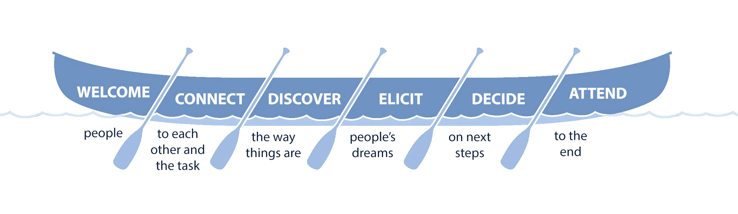

Meetings require each participant to understand the expectations and responsibilities of the role they play in the meeting. It is important to discuss the expectations for each role with meeting participants prior to the start of the meeting. Below is an adapted review from the book *Let’s Stop Meeting like This* of the different roles people can play in a meeting.

|  |  |  |
| --- | --- | --- |
| **Role** | **Responsibilities** | **Keys to Success** |
| Leader | * Convenes the meeting * Assures that the purpose for the meeting is clear and compelling * Assures the right people are present * Leads the meeting, making sure the group stays on task | * Use your power wisely * Invite criticism * Mine for conflict * Make sure the decision-making rules are clear * Be prepared for the meeting |
| Contributor | * Offers ideas and participates in discussion * Brings needed information to the meeting * Acts to facilitate the group’s work effectively | * Take responsibility for the outcomes * Speak your truth * Be open to others’ viewpoints * Be prepared for the meeting |
| Facilitator | * Assist the group in achieving its purpose * Take responsibility for timekeeping or posting information * Promotes all participants’ voices * Helps to resolve conflicts | * Think like a designer – involve participants in the flow of the meeting * Describe what you see and hear when impasses arise * Work to make sure everyone’s voice counts |

# Execute

**Making Decisions**

Meetings can be a crucial tool in helping to make well-founded decisions for an organization. It is important to make sure that when using a meeting to make decisions the group is explicit regarding:

* Who is making the decisions
* How they will make the decisions
* What they are deciding

**Navigating Meeting Pitfalls**

Even when everyone is aware of their roles and responsibilities and there is a great facilitator to move the discussion forward – pitfalls, deadlocks, and impasses can happen in meetings.

*What have you found to be helpful to navigating out of meeting pitfalls?*

**Navigating Meeting Pitfalls**

|  |  |
| --- | --- |
| **Problem** | **Helpful Action** |
| One person constantly talks | Paraphrase their message, ask for confirmation, ask for other opinions |
| Two people argue while others remain silent | “I think we know your viewpoints. I’d like to hear what others have to say.” |
| Two people are locked in conflict | Ask each person to state their understanding of the other person’s viewpoint. |
| The group is off on a tangent | “Is this the work we are supposed to be doing now?” Ask everyone’s opinion of this statement. |
| The group is deadlocked and unable to make a decision | “What would you like to do about the deadlock we are facing?” |
| You have an unclear understating of decisions reached or next steps | “I’m not clear on what we just decided” or “I don’t know what the next steps are” |

# Follow Through

To make sure that everyone leaves the meeting on the same page it is important to:

* Review any decisions made in the meeting
* Assign action items and to-do’s for each person in the meeting
* Create a road map to reach the next stage in planning your work
* Take time to reflect on your meeting and gather feedback about the meeting process

# Establish Ground Rules

All teams have norms – the unwritten and written rules of how you can behave in meetings. Establishing norms with groups that frequently meet, help to ensure there is a reliable process for getting work done together. Ground rules set the stage and expectations for each participant and allow everyone to maintain accountability for achieving the goal and purpose of each meeting.

*What are some ground rules that you have found useful at your meetings?*

# Example Monthly Operations Meeting

|  |  |  |  |  |
| --- | --- | --- | --- | --- |
| Monthly Team Meeting | |  | | --- | | March 17, 2016 | | 8:30 – 10:00 AM | | LC3 1314 | |

|  |  |  |  |
| --- | --- | --- | --- |
| **Meeting called by:** | Jane Andrews, Director | **Type of Meeting:** | Monthly - Operations |
| **Facilitator:** | Frank Davis | **Note taker:** | Jose Garcia |

|  |  |
| --- | --- |
| **Timekeeper:** | Erika Reynolds |
| **Attendees:** | Salma Cruise, Frank Davis, Jose Garcia, Andy Jackson, Erika Reynolds |
| **Please review:** | Attachments: Draft Evaluation Survey, Reporting Software New Requirements Meeting Agenda/Process |
| **Please bring:** | Weekly Priorities & Issues, Hurdles & Opportunities |

## Agenda Items

|  |  |  |
| --- | --- | --- |
| **Topic** | **Presenter** | **Time allotted** |
| * Welcome – Agenda Overview | Jane Andrews | 5 minutes |
| * Safety Message | Susan Reynolds | 10 minutes |
| * Highlights from last week? | Jane Andrews, All | 5 minutes |
| * Round Robin – Top 3 Priorities for coming month in 60 seconds | All | 10 minutes |
| * Issues: |  |  |
| * + Coverage for peak period and storm: June through August; Volunteers? | Salma Cruise | 10 minutes |
| * + New front line training program     - Launch date, enrollment report     - Manager communication templates     - Evaluation survey (input from team) | Andy Jackson | 15 minutes |
| * + Update and impacts of new software reporting system | Jose Garcia | 10 minutes |
| * To-Do’s: Actions/Owner/Deadlines & Deliverables | Frank Davis | 10 minutes |
| * Closing: Hurdles and Opportunities: Roundtable Discussion | All | 15 minutes |

## Important Information

|  |  |  |
| --- | --- | --- |
| Calendar: | April 7 2:00 – 3:30  LC2 106 | * Reporting Software New Requirements Meeting,  (see attached Six Thinking Hats Process, Goals and Agenda) |
| April 18 8:30 – 10:00  LC3 1314 | * Monthly Team Meeting |
| April 21 1:00 – 2:30  LC2 113/114 | * Road Show—Please make a strong showing! |
| May 27 | * Memorial Day Holiday |
| June 7 – 14 | * Andy on vacation |
| FYI: | June 21 – 25 | * Mid-year reviews due to Jane by 5 pm 6/25 |
| July 17 | * Employee Picnic at the Museum of Science and Industry |
| August 8 | * Charity Golf Event at Cantigny, see Frank to purchase tickets |

# Meeting Agenda Activity

Reviewing the agenda on the previous page, discuss the questions below with your group.

*What are the best practices of meetings reflect in the monthly meeting agenda?*

*How can Jane (leader) and Frank (facilitator) build accountability into the meeting?*

*What are some of the things Jane or Frank could do to keep the meeting from going off-track?*

# Assess a Meeting

Take a moment to assess the last meeting you attended (as a leader, contributor, or facilitator) by answering the questions below:

**Using the table below, please check the box corresponding to your answer.**

|  |  |  |  |  |
| --- | --- | --- | --- | --- |
|  | **Always** | **Sometimes** | **Rarely** | **Never** |
| Of all the times this meeting is held, what percent of the time does the meeting advance the work of your organization? |  |  |  |  |
| Of all the times this meeting is held, what percent of the time are the right people included in the meeting? |  |  |  |  |
| Of all the times decisions occur in this meeting, what percent of the time is the decision-making process clear to everyone present? |  |  |  |  |
| Of all of the times this meeting is held, everyone present understands the meeting’s purpose. |  |  |  |  |
| Of all the times this meeting is held, how often does valuable learning occur? |  |  |  |  |
| Do you feel welcome in this meeting? |  |  |  |  |
| Do you feel connected to this meeting’s task? |  |  |  |  |
| When issues arise in the meeting that prevent the group from achieving its purpose, how often does the group work to resolve these issues? |  |  |  |  |
| Of all the times this meeting takes place, how often does the group discuss whether this meeting is time well spent? |  |  |  |  |

When you have finished taking this quick assessment, discuss your assessment and what strategies could be taken to improve meeting planning, participation and results.

*What is a realistic change?*

*What resources might be needed?*

*Where do you begin?*

# Setting Your Agenda Use this for activity

Using the template below, implement the best practices for planning the next session of the meeting you chose to evaluate using the assessment.

|  |  |  |  |  |
| --- | --- | --- | --- | --- |
| My Meeting | |  | | --- | | Date: | | Time: | | Location: | |

|  |  |  |  |
| --- | --- | --- | --- |
| **Meeting called by:** |  | **Type of Meeting:** |  |
| **Facilitator:** |  | **Note taker:** |  |

|  |  |
| --- | --- |
| **Timekeeper:** |  |
| **Attendees:** |  |
| **Please review:** |  |
| **Please bring:** |  |

## Agenda Items

|  |  |  |
| --- | --- | --- |
| **Topic** | **Presenter** | **Time allotted** |
| * Welcome – Agenda Overview |  |  |
|  |  |  |
|  |  |  |
|  |  |  |
| * Issues: |  |  |
|  |  |  |
|  |  |  |
|  |  |  |
| * To-Do’s: Actions/Owner/Deadlines & Deliverables |  |  |
| * Closing: Hurdles and Opportunities: Roundtable Discussion |  |  |

## Important Information

|  |  |  |
| --- | --- | --- |
| Calendar: |  |  |
|  |  |
|  |  |
|  |  |
|  |  |
| FYI: |  |  |
|  |  |
|  |  |

# Group Debrief

Please share your agendas in pairs. Work with each other to improve upon your current meeting agenda.

What things would you like to implement in the next meeting that will be new?

How will you gain buy-in from meeting participants?

What will change in your meetings as a result of today’s training?

# Appendix A: Sample Team Agenda (Source: manager-tools.com)

|  |  |  |  |  |
| --- | --- | --- | --- | --- |
| My Meeting | |  | | --- | | Date: | | Time: | | Location: | |

|  |  |  |  |
| --- | --- | --- | --- |
| **Meeting called by:** |  | **Type of Meeting:** |  |
| **Facilitator:** |  | **Note taker:** |  |

|  |  |
| --- | --- |
| **Timekeeper:** |  |
| **Attendees:** |  |
| **Please review:** |  |
| **Please bring:** |  |

## Agenda Items

|  |  |  |
| --- | --- | --- |
| **Topic** | **Presenter** | **Time allotted** |
| * Welcome – Agenda Overview |  |  |
|  |  |  |
|  |  |  |
|  |  |  |
| * Issues: |  |  |
|  |  |  |
|  |  |  |
|  |  |  |
| * To-Do’s: Actions/Owner/Deadlines & Deliverables |  |  |
| * Closing: Hurdles and Opportunities: Roundtable Discussion |  |  |

## Important Information

|  |  |  |
| --- | --- | --- |
| Calendar: |  |  |
|  |  |
|  |  |
|  |  |
|  |  |
| FYI: |  |  |
|  |  |
|  |  |

# Appendix: Meeting Planning Questions

1. Is this meeting necessary?
2. What do we want to be different because this group of people meets?
3. Who needs to be in the meeting?
4. How do we get people to take ownership of the meeting?
5. What type of meeting does this need to be?

# Appendix: Meeting Effectiveness Assessment

**Using the table below, please check the box corresponding to your answer.**

|  |  |  |  |  |
| --- | --- | --- | --- | --- |
|  | **Always** | **Sometimes** | **Rarely** | **Never** |
| Of all the times this meeting is held, what percent of the time does the meeting advance the work of your organization? |  |  |  |  |
| Of all the times this meeting is held, what percent of the time are the right people included in the meeting? |  |  |  |  |
| Of all the times decisions occur in this meeting, what percent of the time is the decision-making process clear to everyone present? |  |  |  |  |
| Of all of the times this meeting is held, everyone present understands the meeting’s purpose. |  |  |  |  |
| Of all the times this meeting is held, how often does valuable learning occur? |  |  |  |  |
| Do you feel welcome in this meeting? |  |  |  |  |
| Do you feel connected to this meeting’s task? |  |  |  |  |
| When issues arise in the meeting that prevent the group from achieving its purpose, how often does the group work to resolve these issues? |  |  |  |  |
| Of all the times this meeting takes place, how often does the group discuss whether this meeting is time well spent? |  |  |  |  |

*What can I do to improve upon this meeting?*

*What resources might I need?*

*Where do I begin?*

# Appendix: Bibliography and Additional Resources

* *Death by Meeting: A Leadership Fable…About the Most Painful Problem in Business* (Patrick Lencioni)
* *“*Half of All Meetings Are Unproductive. Is There a Fix?” (Marketplace, Nancy Kohen)
* *Let’s Stop Meeting Like This: Tools to Save Time and Get More Done*(Emily and Dick Axelrod)

[Free Management Library](http://managementhelp.org/)

Provides free, easy-to-access, online articles. Over the past 15 years, the Library has grown to be one of the world's largest well-organized collections of these types of articles and resources.

[AxelrodGroup.com](http://axelrodgroup.com/)

Research, articles, blogs and insights from authors, Emily and Dick Axelrod

[TableGroup.com](http://www.tablegroup.com)  
Resources for team building, leadership, and employee engagement.

[Manager-tools.com](http://www.manager-tools.com)    
An online resource that provides podcasts, templates and tools for manager development.

[The](http://lms.exeloncorp.com/plateau/user/deeplink_redirect.jsp?linkId=ITEM_DETAILS&componentID=E-W-ALL-SITLEAD0304&componentTypeID=TRAINING&revisionDate=1415818380000) Art and Science of a 1:1 *at ComEd*

This two-hour workshop gives managers and supervisors tools to become skillful and effective communicators and coaches with their direct reports, colleagues and bosses. The workshop reviews best practices and tools for conducting a 1:1 meeting for employee development.